Real-Time Settlement
# Source: AI Source: Provided by: [Data Path: Persons Table -> ID Column: 1, Name_En Column: Motasem Essam] -> From: [ChatGPT] on [1/21/2026]
Real-time settlement in mobile money refers to the immediate transfer and confirmation of funds between users, merchants, or service providers through mobile wallet systems. The value is reflected instantly in the recipient's account, and the transaction is marked as final and irreversible (in most cases).

🧠 Simple Definition
# Source: AI Source: Provided by: [Data Path: Persons Table -> ID Column: 1, Name_En Column: Motasem Essam] -> From: [ChatGPT] on [1/21/2026]
Real-time settlement means the money moves and becomes available instantly — no delays, no batching. It’s used in peer-to-peer transfers, merchant payments, and mobile top-ups.

📲 How It Works
# Source: AI Source: Provided by: [Data Path: Persons Table -> ID Column: 1, Name_En Column: Motasem Essam] -> From: [ChatGPT] on [1/21/2026]
- User A initiates a mobile money payment (e.g., to a merchant or another user).
- The request is sent to the Mobile Money Provider's backend (e.g., Vodafone Cash).
- The system validates, authorizes, and settles the transaction in real time.
- User B (receiver) gets the funds immediately in their mobile wallet.
✅ This entire process usually completes in 1–3 seconds.

✅ Common Use Cases
# Source: AI Source: Provided by: [Data Path: Persons Table -> ID Column: 1, Name_En Column: Motasem Essam] -> From: [ChatGPT] on [1/21/2026]
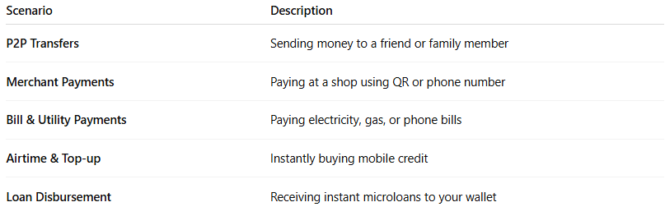

Scenario | Description
P2P Transfers | Sending money to a friend or family member
Merchant Payments | Paying at a shop using QR or phone number
Bill & Utility Payments | Paying electricity, gas, or phone bills
Airtime & Top-up | Instantly buying mobile credit
Loan Disbursement | Receiving instant microloans to your wallet

🌍 Examples of Real-Time Mobile Money Systems
# Source: AI Source: Provided by: [Data Path: Persons Table -> ID Column: 1, Name_En Column: Motasem Essam] -> From: [ChatGPT] on [1/21/2026]
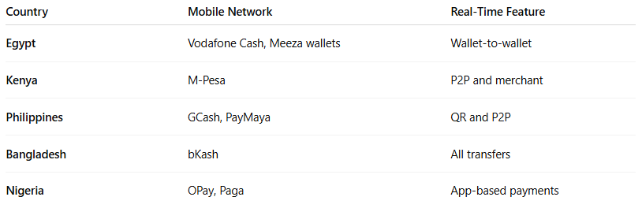

Country | Mobile Network | Real-Time Feature
Egypt | Vodafone Cash, Meeza wallets | Wallet-to-wallet
Kenya | M-Pesa | P2P and merchant
Philippines | GCash, PayMaya | QR and P2P
Bangladesh | bKash | All transfers
Nigeria | OPay, Paga | App-based payments

🔐 Settlement Characteristics
# Source: AI Source: Provided by: [Data Path: Persons Table -> ID Column: 1, Name_En Column: Motasem Essam] -> From: [ChatGPT] on [1/21/2026]
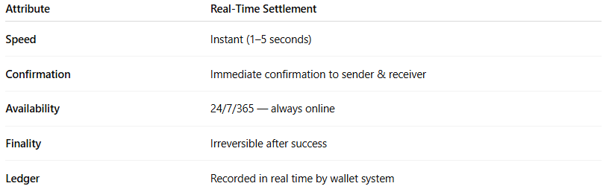

Attribute | Real-Time Settlement
Speed | Instant (1–5 seconds)
Confirmation | Immediate confirmation to sender & receiver
Availability | 24/7/365 — always online
Finality | Irreversible after success
Ledger | Recorded in real time by wallet system

🛡️ Security Features Often Included
# Source: AI Source: Provided by: [Data Path: Persons Table -> ID Column: 1, Name_En Column: Motasem Essam] -> From: [ChatGPT] on [1/21/2026]
- PIN or biometric confirmation
- OTP verification
- SMS or app notifications
- Transaction limits and risk scoring

⚠️ Limitations / Considerations
# Source: AI Source: Provided by: [Data Path: Persons Table -> ID Column: 1, Name_En Column: Motasem Essam] -> From: [ChatGPT] on [1/21/2026]
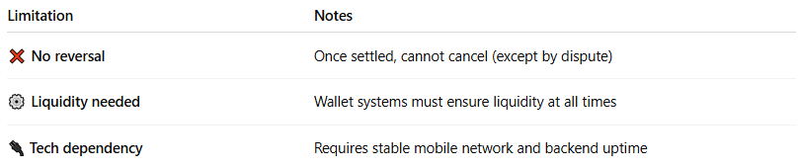

Limitation | Notes
❌ No reversal | Once settled, cannot cancel (except by dispute)
⚙️ Liquidity needed | Wallet systems must ensure liquidity at all times
🔌 Tech dependency | Requires stable mobile network and backend uptime

🧠 Summary
# Source: AI Source: Provided by: [Data Path: Persons Table -> ID Column: 1, Name_En Column: Motasem Essam] -> From: [ChatGPT] on [1/21/2026]
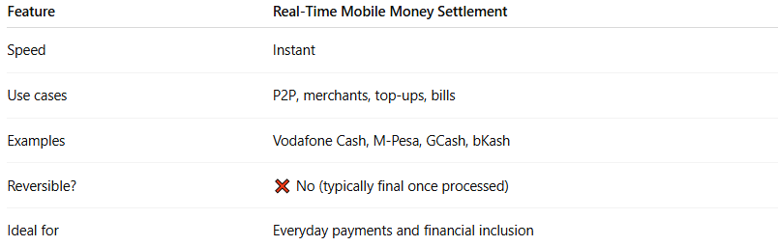

Feature | Real-Time Mobile Money Settlement
Speed | Instant
Use cases | P2P, merchants, top-ups, bills
Examples | Vodafone Cash, M-Pesa, GCash, bKash
Reversible? | ❌ No (typically final once processed)
Ideal for | Everyday payments and financial inclusion

